**Exercise NO 7: Use Google and Whois for Reconnaisasance.**

Aim: To find out the Whois, DNS Records and Diagonstics for particular website by using Whois search.

Procedure:

Step1: Open the WHO.is website



Step 2: Enter the website name in search bar and hit the “Enter button”. Step 3: Show you information about [www.saveetha.com](http://www.saveetha.com/)

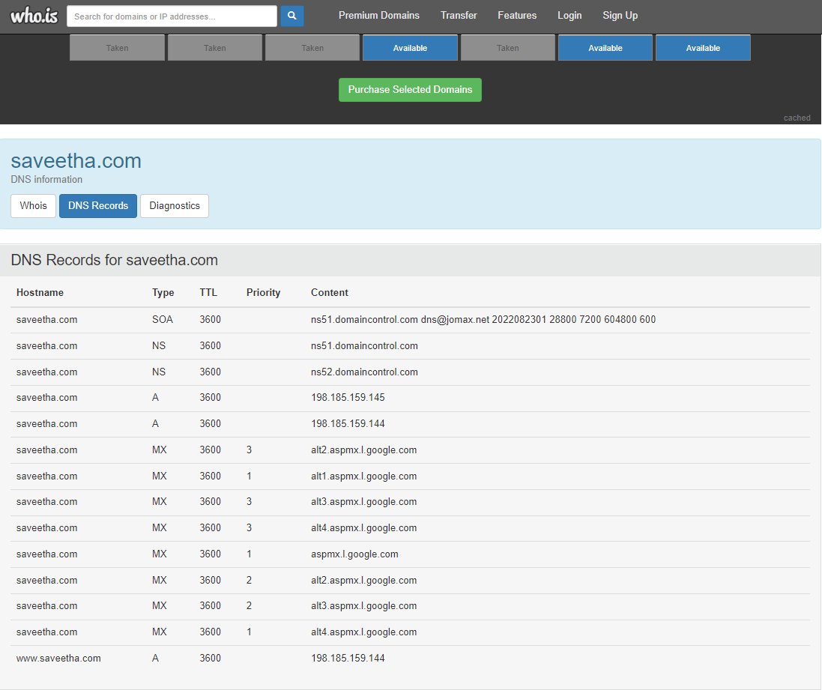

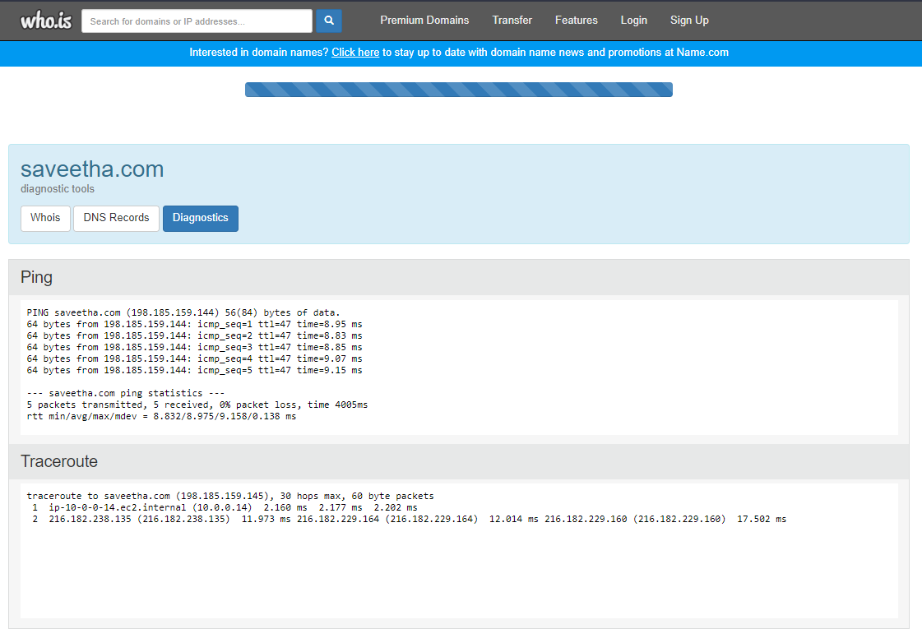

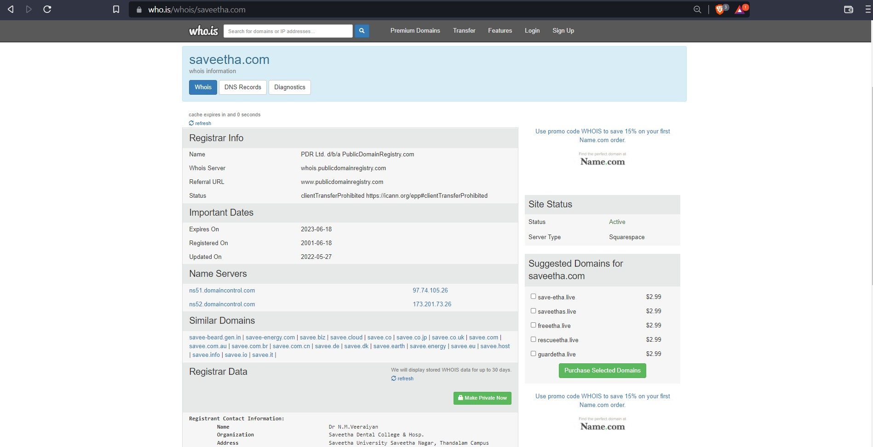

**Output**

1.WHO is

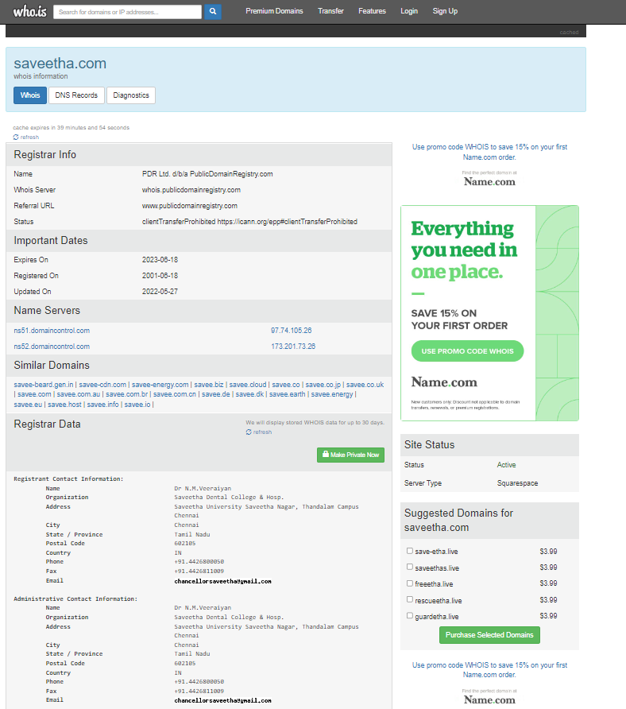

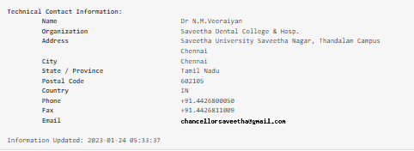

2. DNS

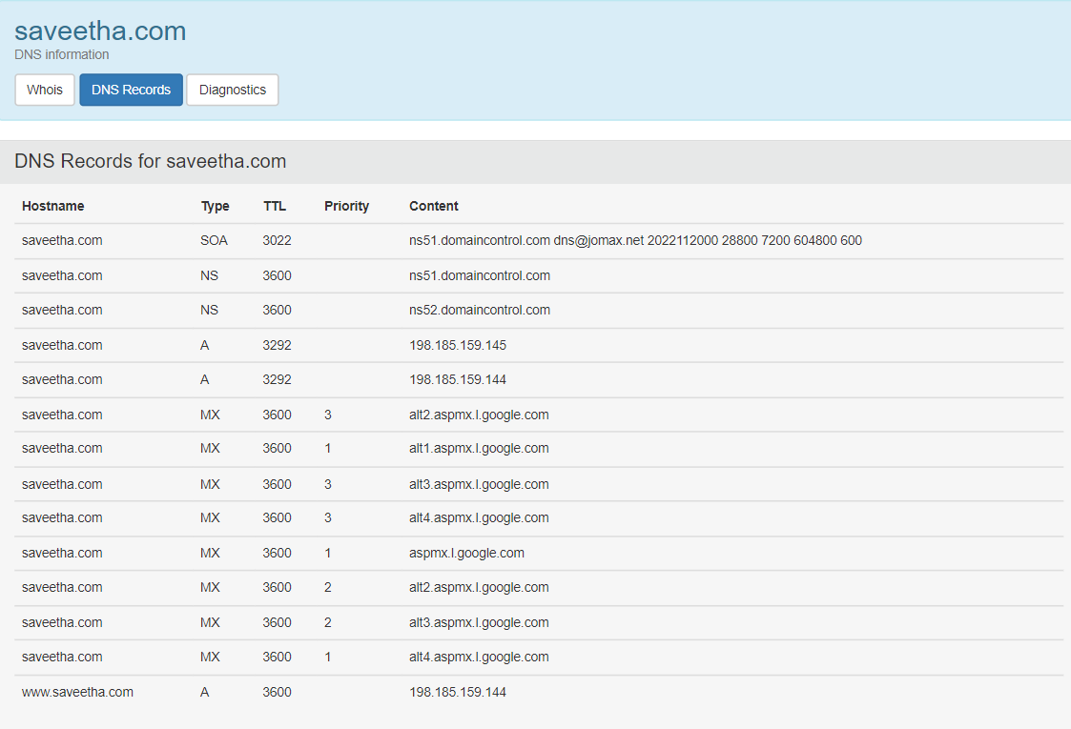

3.Diagnostics

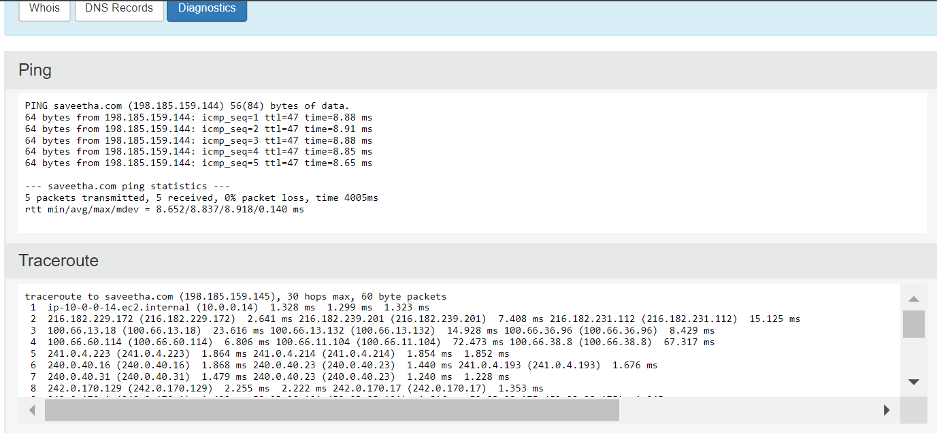

Result

Hence the Whois, DNS Records and Diagonstics for particular website by using Whois search is performed successfully.